Top Tips: Use this press release after your event to let people know how much money your event raised to help those affected by breast cancer.
Edit the sections in pink with your own information and email it to your local newspaper or radio station as soon as you can after your event, along with photos of your Afternoon Tea.
Don’t forget to proof read before sending and remove any pink text and instructions.
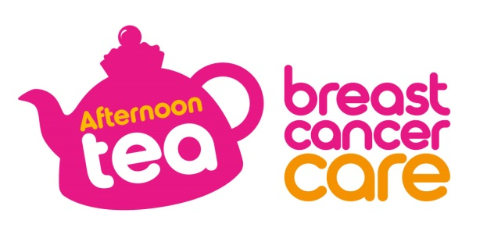

[Insert date]
[Insert name of town/area] [Woman/ man/ group/ shop] raised [£XXX] to support people affected by breast cancer
[Name] from [Location] held an Afternoon Tea at [Venue] and raised an amazing total of [£XXX] for Breast Cancer Care¹ which will help the charity continue to fund breast cancer research and support for people affected by breast cancer.
[Name], [age] held a tea on [date] because [Select any of the following 3 options, feel free to expand: he/she has a friend/family member who has had breast cancer. OR he/she was diagnosed with breast cancer. OR he/she wanted to support the charity].
[Name] who works as a [Occupation] says: “Everyone had a wonderful time at the Afternoon Tea, around [number] people joined us. I’d like to thank everyone who baked treats and helped out and I am truly grateful to all those who supported us and donated to Breast Cancer Care, it means so much.”
Lydia Scott, Afternoon Tea Manager at Breast Cancer Care, added: ““We are so thankful to [Name] for hosting such a wonderful event. The funds raised will help Breast Cancer Care to continue to provide vital breast cancer research and free support services to the 62,000² people diagnosed with breast cancer each year. We hope [Name]’s success will encourage lots more [Location] residents to hold their own Afternoon Tea!”
If you’d like to hold your own Afternoon Tea you can order your free fundraising kit at www.breastcancercare.org.uk/cuppa or call 0300 100 4442.
– Ends –

For further information, images or interviews contact:
[Name], [Phone number], [Email address]

Notes to Editors
¹ Breast Cancer Care is a working name of Breast Cancer Care and Breast Cancer Now, a charity registered in England and Wales (1160558) and Scotland (SC045584).
² This number combines invasive breast cancer and DCIS.
About Breast Cancer Care
Breast Cancer Care is the only specialist UK wide charity providing support for women, men, family and friends affected by breast cancer. We’ve been caring for them, supporting them, and campaigning on their behalf since 1973.
We offer a unique range of support including reliable information, one-to-one support over the phone and online from nurses and people who’ve been there. We also offer local group support across the UK.
In April 2019, Breast Cancer Care and Breast Cancer Now merged to create one charity for everyone affected by breast cancer. By uniting the UK’s largest breast cancer research charity with the UK’s leading breast cancer support charity, we can make sure that one day, everyone who develops breast cancer will live and receive the care, support and information they need to live well.
Visit breastcancercare.org.uk or follow us on Twitter, Facebook or Instagram

