Top Tips: Use this press release before your event if you would like to invite people in your area to attend. Edit the sections in pink with your own information and email it to your local newspaper and radio station around two weeks before your event. Don’t forget to proof read before sending and remove any pink text and instructions.
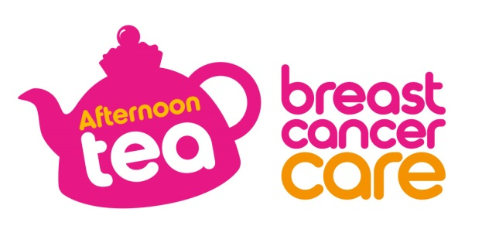

[Insert date]
[Insert name of town/area] [Woman/ man/ group/ shop] to host Afternoon Tea to support people affected by breast cancer
[Name] from [Location] is hosting an Afternoon Tea at [Venue] on [Date] to raise money for Breast Cancer Care to fund research and support for people affected by breast cancer.
[Name], [Age] is holding [his/her/their] [first/second/third/ annual] Afternoon Tea and is encouraging people to come along and support the charity.
[Name] who works as an [occupation] says: [Select any of the following three options, edit or expand if you want].
“My [family member/friend] was diagnosed with breast cancer in [month/year] and I am looking forward to giving something back by hosting an Afternoon Tea to raise money for Breast Cancer Care.”
OR “I was diagnosed with breast cancer in [month/year] and I am looking forward to hosting an Afternoon Tea to say thank you to my friends and family for their support, while raising money for Breast Cancer Care.”
OR “We are looking forward to holding an Afternoon Tea as it’s a fun way to bring together people from the local community while also raising money for Breast Cancer Care.”
“We’d love locals to join us for some delicious scones, sandwiches and cakes. [Include if relevant]: There will also be games and competitions too so there’s something for everyone.”
Georgie Gibbons, Afternoon Tea Manager Breast Cancer Care, added: “We’re so grateful to everyone who holds an Afternoon Tea in aid of Breast Cancer Care this summer. The money raised will fund pioneering research and life-changing support and care for the 691,000 people living with breast cancer in the UK today.”
If you would like to attend [Name]’s Afternoon Tea, please call [phone number]
OR
[Name]’s Afternoon Tea is being held at [Full address] on [insert date] between [time-time]/ at [time], locals are welcome to drop by.
If you’d like to hold your own Afternoon Tea you can order your free fundraising kit at www.breastcancercare.org.uk/cuppa or call 0300 100 4442.
– Ends –

For further information, images or interviews contact:
[Name], [Phone number], [Email address]

About Breast Cancer Care
Breast Cancer Care is the only specialist UK wide charity providing support for women, men, family and friends affected by breast cancer. We’ve been caring for them, supporting them, and campaigning on their behalf since 1973.
We offer a unique range of support including reliable information, one-to-one support over the phone and online from nurses and people who’ve been there. We also offer local group support across the UK.
In April 2019, Breast Cancer Care and Breast Cancer Now merged to create one charity for everyone affected by breast cancer. By uniting the UK’s largest breast cancer research charity with the UK’s leading breast cancer support charity, we can make sure that one day, everyone who develops breast cancer will live and receive the care, support and information they need to live well.
Visit breastcancercare.org.uk or follow us on Twitter, Facebook or Instagram

